* Window -> workspace, here we can edit our layout
* Transform, Align, Swatches, Color, Gradient, Stroke, layers and the character tab are mostly used, rest we can pull up when we need.
* We can select multiple objects by holding shift. We can right click after selecting and create a group.

**Rectangle tool:** We can draw different shapes here.

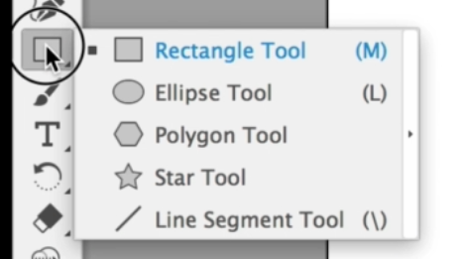

**Stroke and fill:** Inside are the stroke and outside is the fill, we can change the color from the bottom, where two little rectangle icons.

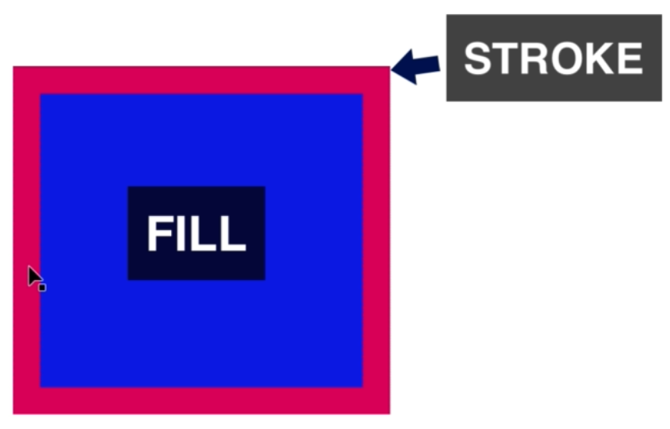 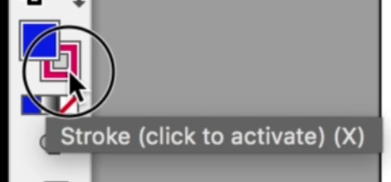

* We can adjust stroke options from the stroke window, things like size, cap, corner, align stroke etc.
* Just below the stroke/fill color icons on the left, there is 3 options for showing color, gradient or none. None is kind of like CSS display none option.
* To make a **perfect circle**, we have to hold the **shift key** while drawing.

**Anchor Point:** When we select an object, we can see all the anchor points. We can click any of the anchor points and manipulate it in any way we want.

**Pen Tool:** This tool helps us manipulate the anchor points to make a wide variety of shapes. There is tool called smart guides, which will let us use pen tool with precision.

* Using pen tool, we can create a rounded shape. After the first anchor point, when we about to click the 2nd anchor point to make a line (or whatever shape) we can hold the mouse button and change the shape.